Miguel Tirado

Professor Rudametkin

ENGR117-06

10/10/2018

Lab 4 Pre-Lab: P-Spice

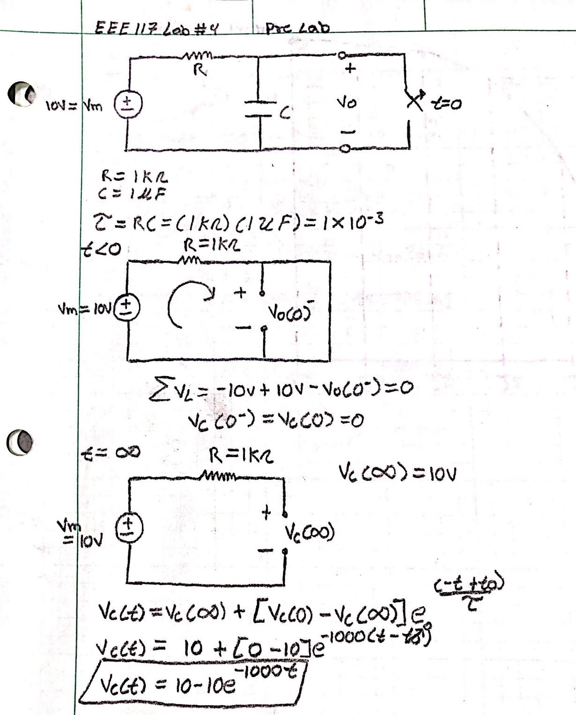

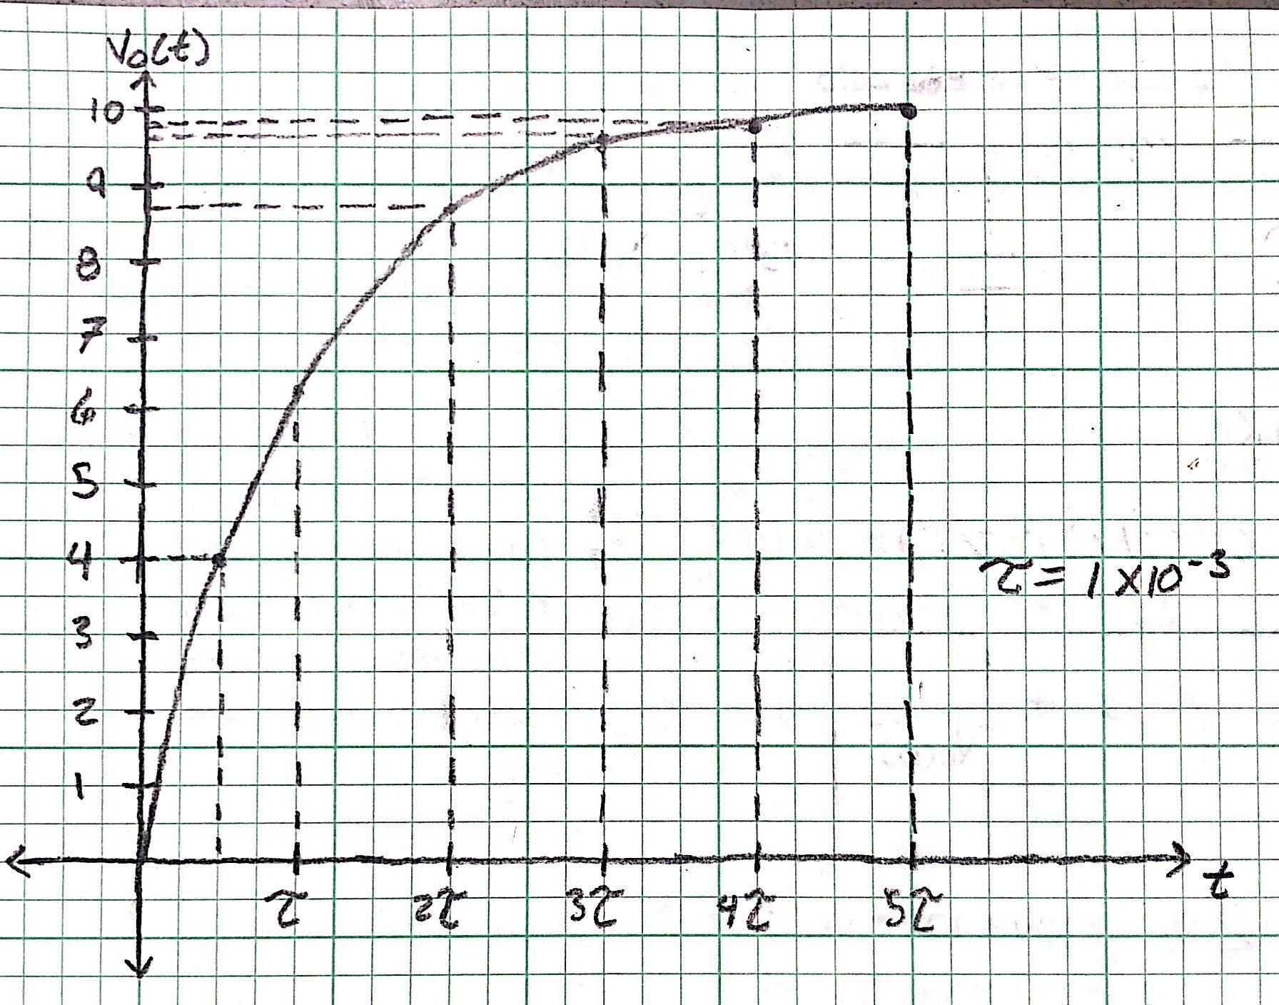

**S. Aguilar Rudametkin**